WHAT IS THE TIME FRAME FOR THE PLANNING PROCESS?
Like all other planning efforts, adaptation planning requires time and effort. Local government agency staff and other stakeholders will need to commit their time, technical and financial resources, and the available knowledge of everyone involved to ensure a successful process.
The time frame for the adaptation planning process may be determined by a grant, budget cycle, direction from elected officials, community priorities, or other factors. The breakdown of the adaptation planning process in Table 4 of the Adaptation Planning Guide, shown below, shows the phases and steps in this guide and estimates the timing of each step. Steps may take more or less time depending on capacity, funding, scope details, and other characteristics. Following all phases could take 12 to 24 months, depending on the level of detail and resources committed to each phase. It is also possible to work on more than one step at the same time.
Considerations that can affect the time frame of the process are:
- Staff Capacity: Availability of local agency staff and other stakeholders who will lead and/or participate in the planning process.
- External Support: Need for external support from consultants, community partners, or other external partners to complete the process.
- Data: Data availability from internal and external providers and whether any new technical studies are needed.
- Community Engagement: Commitment to community and stakeholder engagement (beyond those who are leading the process), including types and timing of events and opportunities. As discussed in Step 1.4, providing opportunities for stakeholder engagement can be critical to ensuring the success of an adaptation planning project.
- External Review: Requirements for review and participation by external agencies. Some planning mechanisms, such as general plan safety elements or local hazard mitigation plans, require review by external agencies that can take many months.

DRAFT A PLANNING PROCESS WORKPLAN AND TIMELINE
Use the template workplan on the next page to fill in the description and time frame columns with details specific to your planning process, taking into account the considerations listed above and using the Table 4 time frames as a guide. (This table can also be copied into an Excel sheet).

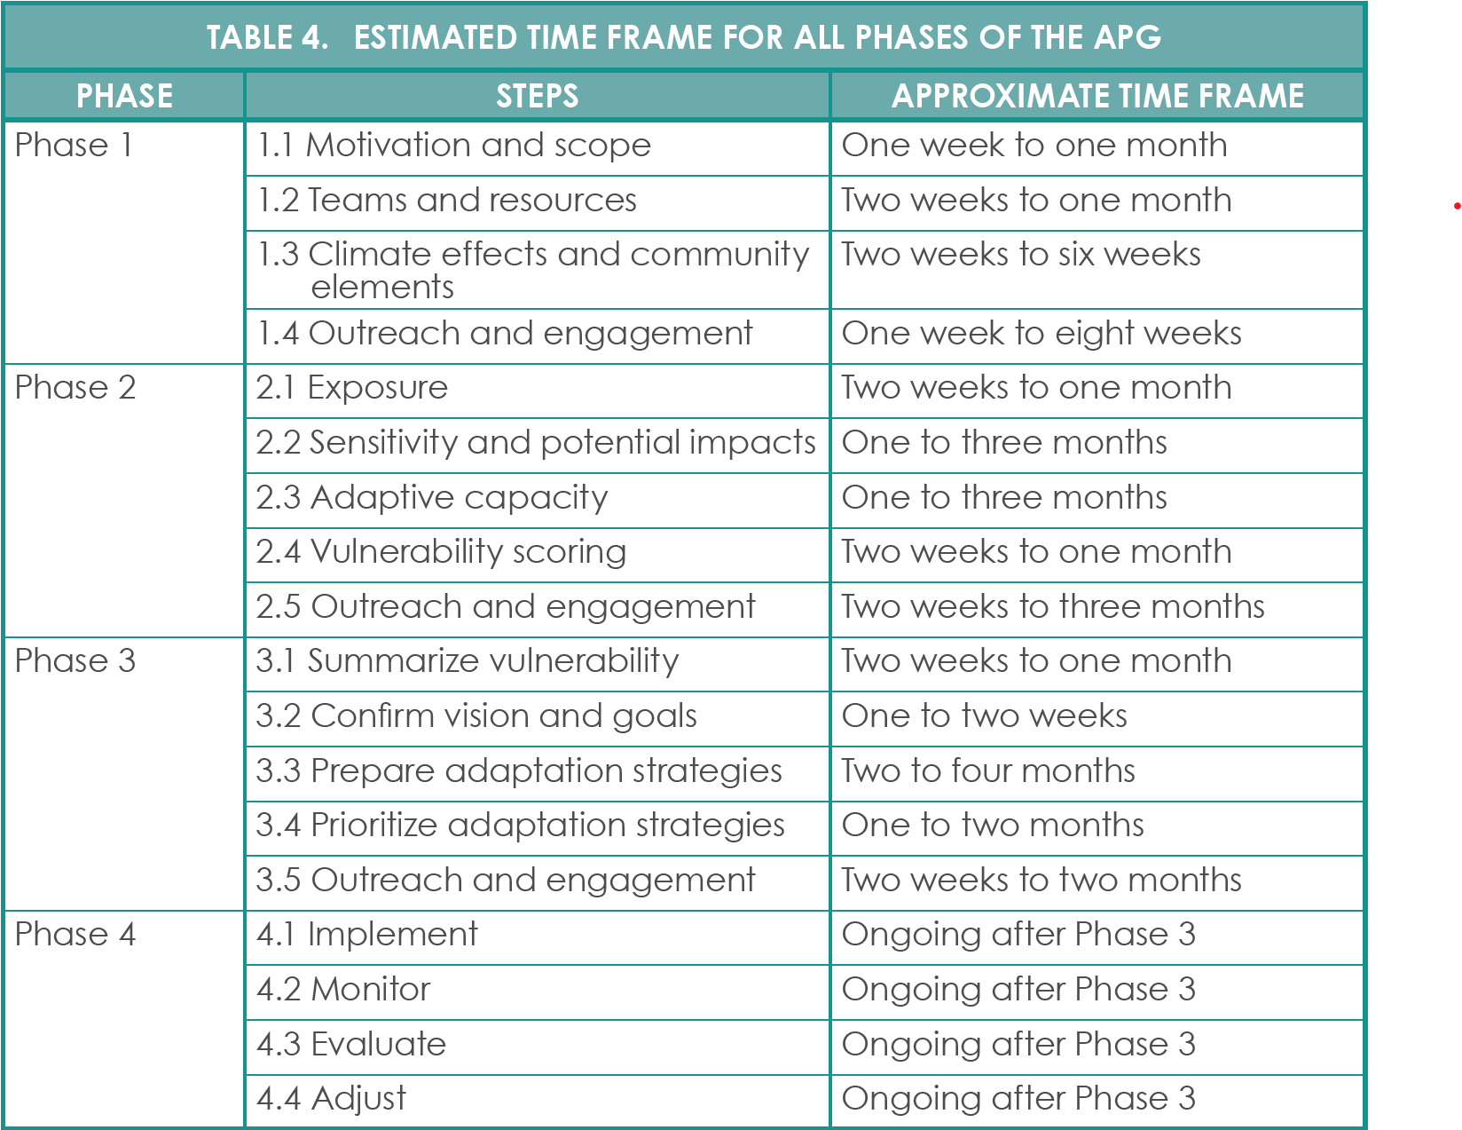

Adaptation Planning Process Draft Workplan

Phase | Step | Description | Time Frame
Phase 1 | 1.1 Motivation and scope
 | 1.2 Teams and resources
 | 1.3 Climate effects and community elements
 | 1.4 Outreach and engagement
Phase 2 | 2.1 Exposure
 | 2.2 Sensitivity and Potential Impacts
 | 2.3 Adaptive capacity
 | 2.4 Vulnerability Scoring
 | 2.5 Outreach and Engagement
Phase 3 | 3.1 Summarize vulnerability
 | 3.2 Confirm vision and goals
 | 3.3. Prepare adaptation strategies
 | 3.4 Prioritize adaptation strategies
 | 3.5 Outreach and engagement
Phase 4 | 4.1 Implement
 | 4.2 Monitor
 | 4.3 Evaluate
 | 4.4 Adjust

